## 

Proposal for AI Teaching Assistant System

12.06.2024

_

**Prepared by:** Innovacio Technologies

Osama Raushan

Director

Innovacio Technologies Pvt. Ltd.

36, Beck Bagan Row,

Near Quest Mall,

West Bengal, Kolkata- 700 017

+91 90072 71601

hello@innovaciotech.com

Thank you for this amazing opportunity and for taking us into consideration for working with you. This looks like an exciting and stimulating project.

# Project Overview

This proposal outlines the development of an AI Teaching Assistant System that leverages a local knowledge base, general AI large models, and multiple interfaces to facilitate student Q&A and resource recommendations. The system will support the Chinese language and integrate with a Learning Management System (LMS).

# Scope of Work

## Functional Requirements

#### Overall Needs

The system will allow students to independently ask questions and receive resource recommendations using an AI model. It will use both a local knowledge base and a general AI model.

#### Backend Functions

1. Knowledge Base Management:
   * Upload, delete, and update text, video, and other resources.
2. Student Information Management:
   * Manage student details including registered names, classes, student numbers, and Q&A records.
3. Evaluation System:
   * Students can provide positive or negative feedback on AI answers.
   * Teachers can review feedback and categorize it.
   * Teachers can update the knowledge base to improve AI responses based on feedback.

#### Front-end Functions

1. Student Q&A Interface:
   * WeChat chatbot using a separate WeChat ID.
   * WeChat Mini Program.
   * Web page interface.

#### Sample Page Requirements

* Knowledge base upload page to upload text, video, and other resources.
* Web page Q&A interface.

#### Deployment Requirements

* The system should support cloud or local deployment.
* Capable of handling at least 500 concurrent users.

#### Technology Stack Requirements

1. Development Language:
   * Python or Node.js.
2. Knowledge Enhancement:
   * Using the LangChain framework.
3. Vector Database:
   * Using FAISS.
4. Graph Database:
   * Using Neo4j.
5. AI Model:
   * Using Tongyi Qianwen.

#### Other Requirements

* Provide source code, programming documentation, and deployment documentation to facilitate paper writing.

# Detailed Plan

## Phase 1: Requirements Analysis

1. **Understand Specific Needs**:
   * Gather detailed requirements from stakeholders.
   * Define the scope of the local knowledge base.
   * Identify specific LMS integration points.
2. **Technical Feasibility**:
   * Assess the feasibility of using Tongyi Qianwen for the AI model.
   * Evaluate cloud and local deployment options.

## Phase 2: Design

1. **System Architecture**:
   * Design the overall system architecture integrating Django, Neo4j, and LangChain.
2. **Database Schema Design**:
   * Design schemas for the Neo4j graph database and FAISS vector database.
3. **Interface Design**:
   * Design UI/UX for the WeChat chatbot, Mini Program, and web interface.

## Phase 3: Development

1. **Backend Development**:
   * Implement knowledge base management using Django.
   * Develop student information management and evaluation system.
2. **Frontend Development**:
   * Develop WeChat chatbot interface.
   * Develop WeChat Mini Program.
   * Develop web page interface.
3. **AI Integration**:
   * Integrate Tongyi Qianwen with the LangChain framework.
   * Implement vector search with FAISS.

## Phase 4: Testing

1. **Unit Testing**:
   * Test individual components for functionality.
2. **Integration Testing**:
   * Ensure all components work together seamlessly.
3. **User Acceptance Testing (UAT)**:
   * Conduct UAT with a sample group of students and teachers.

## Phase 5: Deployment

1. **Cloud/Local Deployment Setup**:
   * Prepare cloud infrastructure or local servers.
   * Deploy the system ensuring scalability for at least 500 users.
2. **Performance Testing**:
   * Conduct load testing to ensure the system can handle the required number of concurrent users.

## Phase 6: Documentation and Training

1. **Documentation**:
   * Prepare detailed source code documentation.
   * Provide comprehensive deployment documentation.
   * Create user manuals for students and teachers.
2. **Training**:
   * Conduct training sessions for teachers on using the system and updating the knowledge base.

## Phase 7: Maintenance and Support

1. **Ongoing Support**:
   * Provide technical support for any issues.
2. **System Updates**:
   * Regularly update the system based on user feedback and new requirements.

# Team Structure

## Project Team

1. **Project Manager:** Oversees project timelines, deliverables, and coordination between team members and stakeholders.
2. **Backend Developers:** Focus on developing the backend functionalities using Django, Neo4j, and integrating the AI model.
3. **Frontend Developers:** Develop the WeChat chatbot, Mini Program, and web interface.
4. **AI/ML Engineers:** Customize and integrate the Tongyi Qianwen model, and implement knowledge enhancement with LangChain.
5. **Database Engineers:** Implement and manage the FAISS vector database and Neo4j graph database.
6. **QA Engineers:** Conduct unit, integration, and performance testing.
7. **DevOps Engineers:** Handle deployment, scalability, and maintenance of the system.

# Agile Methodology

We will adopt an Agile methodology, following these key principles:

1. Iterative Development: Develop the project in sprints, each lasting 2-3 weeks.
2. Continuous Feedback: Regularly gather feedback from stakeholders and end-users.
3. Incremental Delivery: Deliver functional modules in each sprint for early testing and validation.
4. Collaboration and Communication: Maintain constant communication within the team and with stakeholders.

## Sprint Structure

1. Sprint Planning: Define the goals and tasks for the upcoming sprint.
2. Daily Stand-ups: Short meetings to discuss progress, roadblocks, and next steps.
3. Sprint Review: Demonstrate the completed work to stakeholders and gather feedback.
4. Sprint Retrospective: Reflect on the sprint to identify what went well and what could be improved.

# Timeline

### **Phase 1: Requirements Analysis (1 weeks)**

* Understand specific needs
* Technical feasibility assessment

### **Phase 2: Design (2 weeks)**

* System architecture design
* Database schema design
* Interface design

### **Phase 3: Development (7 weeks)**

* Backend development (2 weeks)
* Frontend development (2 weeks)
* AI integration (3 weeks)

### **Phase 4: Testing (3 weeks)**

* Unit testing (1 weeks)
* Integration testing (1 week)
* User acceptance testing (1 week)

### **Phase 5: Deployment (1 weeks)**

* Cloud/local deployment setup
* Performance testing

### **Phase 6: Documentation and Training (2 weeks)**

* Prepare documentation
* Conduct training sessions

### **Phase 7: Maintenance and Support (Ongoing)**

* Provide technical support
* Regular updates

# Questions/Thoughts

1. **Scope of the Knowledge Base:**
   * What types of resources will be included? Are there specific formats or standards?
2. **LMS Integration:**
   * What specific LMS systems will we need to integrate with?
3. **AI Model Customization:**
   * To what extent will Tongyi Qianwen need to be customized for this application?
4. **Feedback Mechanism:**
   * How will negative feedback be categorized and managed by teachers?
5. **Performance Requirements:**
   * What specific performance metrics do we need to meet (e.g., response time, system uptime)?
6. **User Load Testing:**
   * Are there specific peak usage times we need to account for in our load testing?

# Deliverables

**Deliverable 1:** Project Architecture setup and Design (Database and Design) **- 1st Month**

**Deliverable 2:** Frontend and Backend Development and deployment **- 2nd Month**

**Deliverable 3:** AI Development and Integration **- 3rd Month**

**Deliverable 4:** Testing and whole project deployment **- 4th Month**

# Addressing Your Questions

1. **Chinese Language AI Model**:
   * We will collaborate with your office team for the integration of the Chinese language AI model (Tongyi Qianwen) if needed.
2. **WeChat Mini Program**:
   * We have experience developing WeChat Mini Programs, ensuring seamless interaction and user experience.
3. **LangChain Framework**:
   * We have expertise in using the LangChain framework for knowledge enhancement and can integrate it effectively into the system.
4. **FAISS for Vector Database**:
   * We are proficient in implementing and managing FAISS for efficient vector searches and database operations.
5. **Neo4j for Graph Database**:
   * We have experience using Neo4j and can leverage it for managing relationships and connections within the data effectively.
6. **Tongyi Qianwen**:
   * Although we haven't directly worked with Tongyi Qianwen, we will collaborate with your in-house team to ensure its successful integration and customization as needed.

# Team Structure and Number of Developers

## Core Team Members and Roles

1. **Project Manager** (1):
   * Oversees project timelines, deliverables, and coordination between team members and stakeholders.
2. **Backend Developers** (1):
   * Focus on developing the backend functionalities using Django, Neo4j, and integrating the AI model.
3. **Frontend Developers** (1):
   * Develop the WeChat chatbot, Mini Program, and web interface.
4. **AI/ML Engineers** (1):
   * Customize and integrate the Tongyi Qianwen model, and implement knowledge enhancement with LangChain.
5. **Database Engineers/ DevOps Engineers** (1):
   * Implement and manage the FAISS vector database and Neo4j graph database.
   * Handle deployment, scalability, and maintenance of the system
6. **QA Engineers** (1):
   * Conduct unit, integration, and performance testing.

## Total Number of Developers

* **Core Development Team**: 4 developers
  + Backend Developers: 1
  + Frontend Developers: 1
  + AI/ML Engineers: 1
  + Database Engineers: 1

This structure ensures a balanced workload and expertise across all areas of the project, allowing us to meet the project requirements and deliver a high-quality AI Teaching Assistant System.

# Similar Project URL

**Here is some general examples of our work in related domains:**

* **AI-Powered Educational Tools**: We have developed AI-driven platforms for educational purposes, including automated essay grading systems and personalized learning assistants.

<https://virtualwritingtutor.com/>

**Also you can check our portfolio here:**

<https://docs.google.com/document/d/1X5X5TJO-RJ9pfMhoMDx426URA2x8F8R8UO-OA0ekI_k/edit?usp=sharing>

If you need more specific case studies or details, we can arrange a meeting to discuss past projects and their outcomes in more detail.  
  
 **Commercials :**

| Component | % | Amount (USD) |
| --- | --- | --- |
|  |  |  |
| Advance | 15 % | 1800 |
|  |  |  |
| **Deliverable 1: Project Architecture setup and Design (Database and Design) - 1st Month** | 20 % | 2400 |
|  |  |  |
| **Deliverable 2: Frontend and Backend Development and deployment - 2nd Month** | 25 % | 3000 |
|  |  |  |
| **Deliverable 3: AI Development and Integration - 3rd Month** | 25% | 3000 |
| **Deliverable 4: Testing and whole project deployment - 4th Month** | 15 % | 1800 |
| Total amount |  | 12000 |

## ***Listen to what other clients are talking about us* 👍 Clutch.co**

## **Goodfirms**

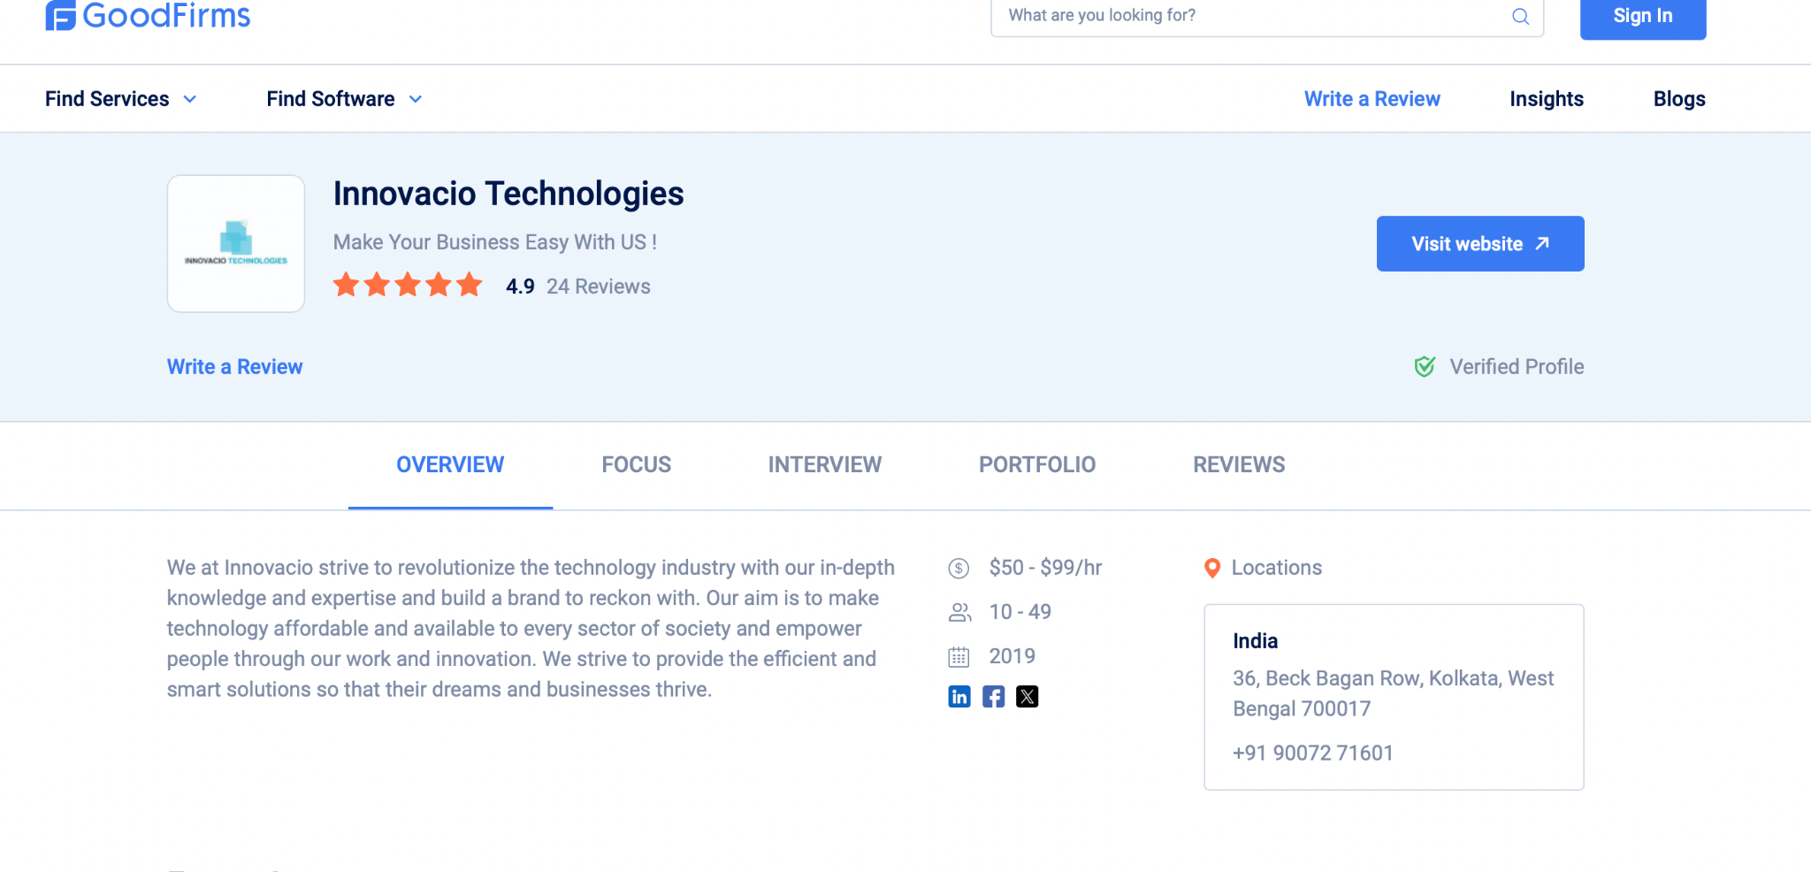

# Design Rush

Please let us know if you need any further information or proposal. We look forward to the opportunity to work with you on this project.

# Thank you!

## Innovacio Technologies Pvt. Ltd.

(CIN) U72900WB2022PTC256303

[hello@innovaciotech.com](mailto:hello@innovaciotech.com)

www.innovaciotech.com